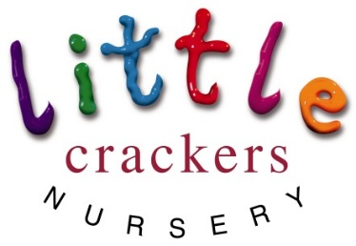
Weekly News

8thSeptember 2017

Next week we will be thinking about…

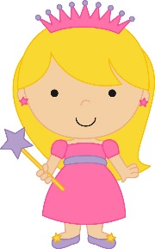 | Pirates and Princesses

We will be
Reading stories, drawing pictures and making treasure maps, digging for treasure in the sand, floating ships, writing messages in bottles, collecting pirates, princesses, and parrots to put in a collection of things that start with p… and… dressing up!!!!

Please can you send in a small plastic bottle to put a message in… and come in dressed up as a pirate or a princess on Friday!!! | Joke of the week:  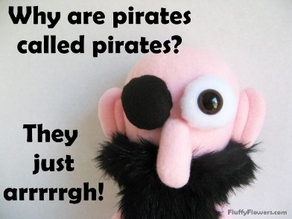
- If you have calpol… stay away from nursery for 24hrs please
- If you have antibiotics… stay away from nursery for 48hrs please

New Session times:  Morning: 7.45-12.45 Afternoon: 1.00-6.00  Free entitlement sessions:  Morning: 8.15-11.15 Afternoon: 12.30-3.30 | Please remember to leave spare clothes in a drawstring bag on your child’s peg Thank you!
Car parking:  Please use the bottom carpark or the road at all times from now on the staff carpark is not to be used at any time, Thank you. | We will get messy in nursery! Please don’t send your child in their best clothes or shoes, easy wash and wear things are ideal.

Little Crackers Nursery · Crackley Hall · St Joseph’s Park · Kenilworth · CV8 2FT
Telephone: 01926 514444 · Fax: 01926 514455 · e-mail: littlecrackers@crackleyhall.co.uk
www.crackleyhall.co.uk

Registered Charity Number 1087124 Company limited by guarantee Number 4177718

